

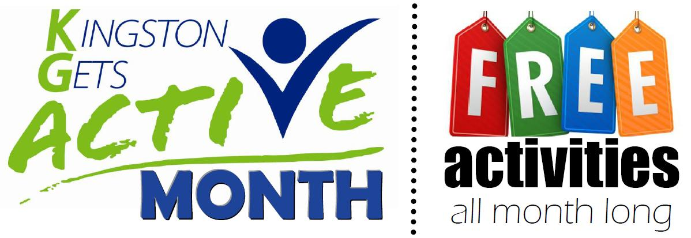

2019

September

 

View the Full calendar at:

www.KingstonGetsActive.ca

AT OLMC

Activity: DANCEPL3Y class for Parents and Kids

Date: September 26, 2019

Time: 4-5 pm